**Day 9**

// Program to find Factorial of a number using static method

class Factorial

{

static int factorial(int num)

{

int fact =1;

for(int i=1;i<=num;i++)

{

fact = fact*i;

}

System.out.println("Factorial of number "+num+" is "+fact);

return fact;

}

public static void main(String args[])

{

Factorial.factorial(5);

}

}

**Output**

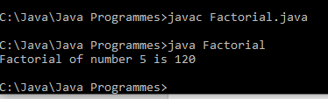

// Program to find Palindrom using Static Method

class Palindrome

{

static int rev=0;

static int rem=0;

static int num;

static int palindrome(int n)

{

num=n;

System.out.println("The number is "+num);

do

{

rem = num%10;

rev = rev*10+rem;

num = num/10;

}while(num>0);

System.out.println("The reverse of the number is "+rev);

if(rev==n)

{

System.out.println("The number is a palindrome number");

return rev;

}

else

{

System.out.println("The number is not a palindrome number");

return rev;

}

}

public static void main(String args[])

{

Palindrome.palindrome(123);

}

}

**OUTPUT**

